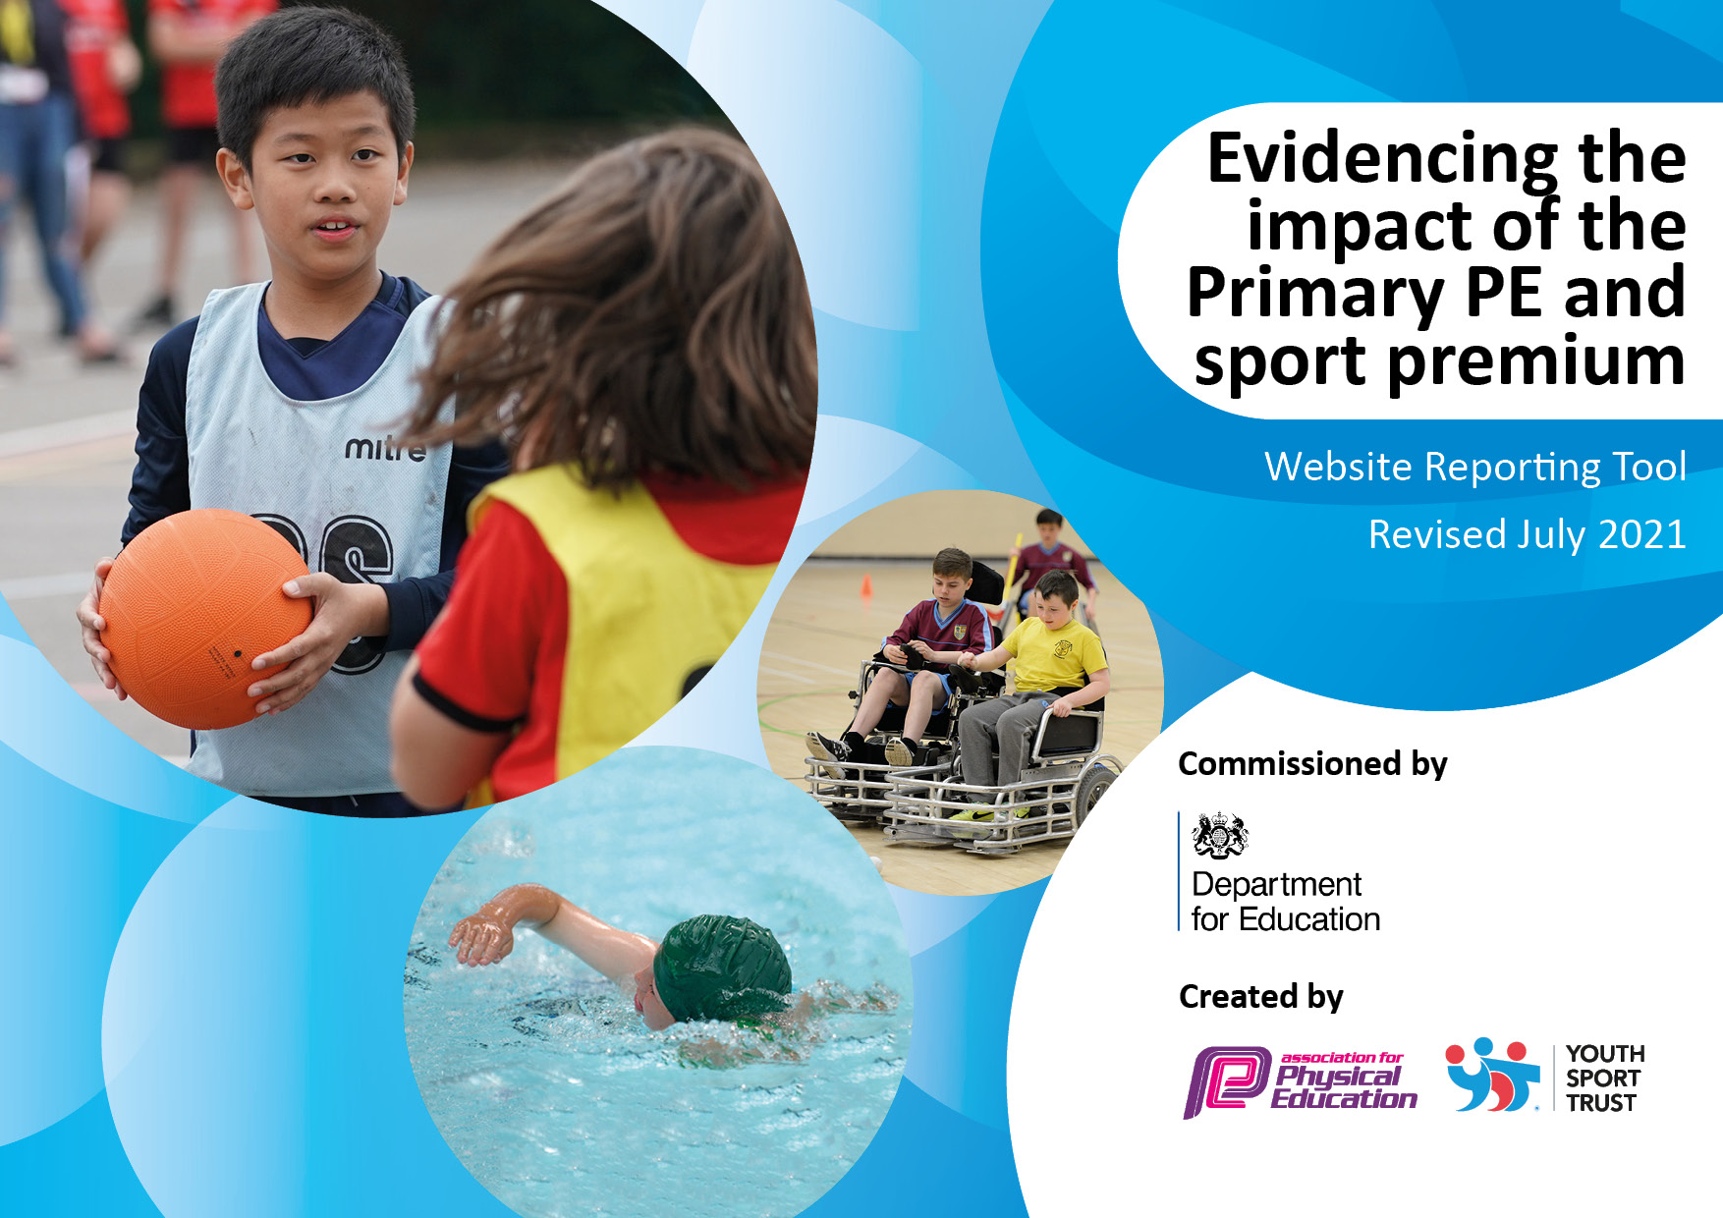
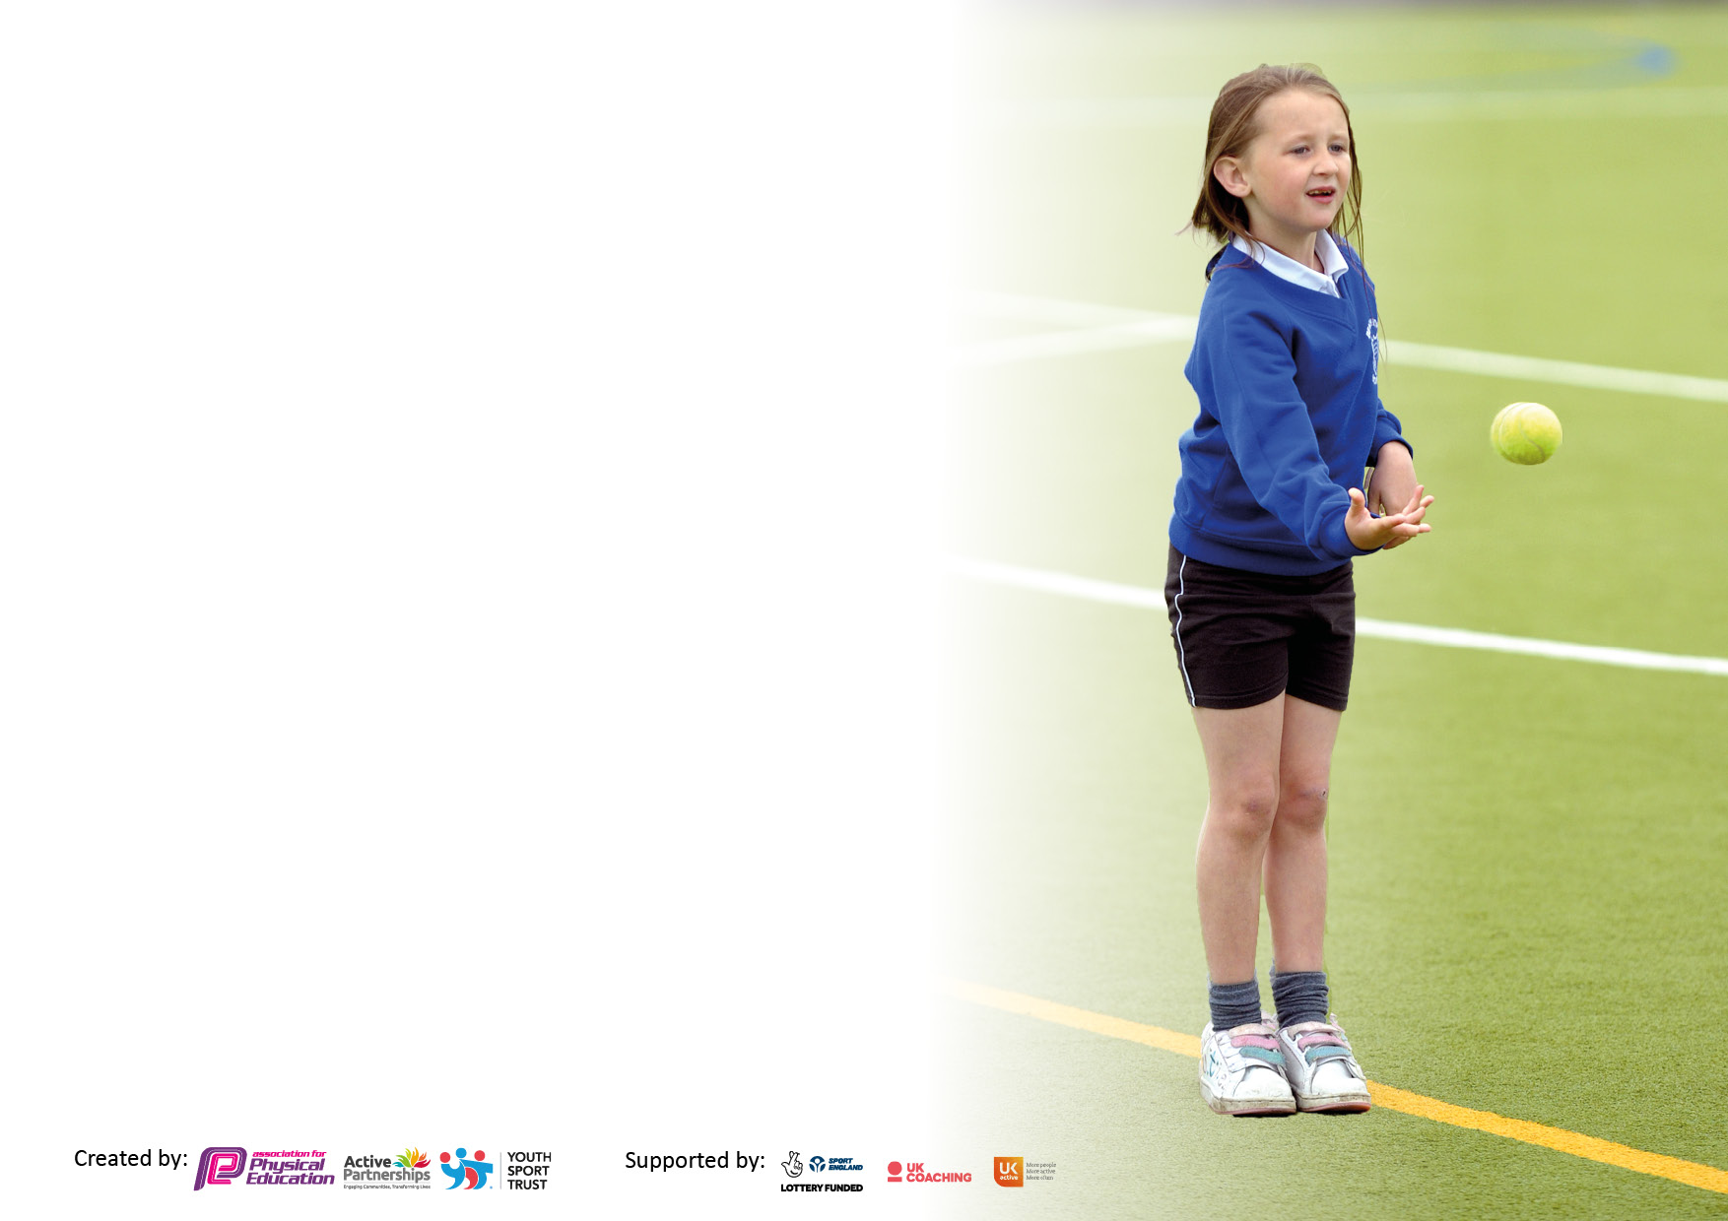

It is important that your grant is used effectively and based on school need. The Education Inspection Framework makes clear there will be a focus on ‘whether leaders and those responsible for governors all understand their respective roles and perform these in a way that enhances the effectiveness of the school’.

Under the Quality of Education Ofsted inspectors consider:
Intent - Curriculum design, coverage and appropriateness
Implementation - Curriculum delivery, Teaching (pedagogy) and Assessment
Impact - Attainment and progress

To assist schools with common transferable language this template has been developed to utilise the same three headings which should make your plans easily transferable between working documents.

Schools must use the funding to make additional and sustainable improvements to the quality of Physical Education, School Sport and Physical Activity (PESSPA) they offer. This means that you should use the Primary PE and sport premium to:

- Develop or add to the PESSPA activities that your school already offer
- Build capacity and capability within the school to ensure that improvements made now will benefit pupils joining the school in future years
- The Primary PE and sport premium should not be used to fund capital spend projects; the school’s budget should fund these.

Pleasevisitgov.ukfortherevisedDfEguidanceincludingthe5keyindicatorsacrosswhichschoolsshoulddemonstrate animprovement.Thisdocumentwillhelpyoutoreviewyourprovisionandtoreportyourspend.DfEencouragesschools to use this template as an effective way of meeting the reporting requirements of the Primary PE and sport premium.

We recommend you start by reflecting on the impact of current provision and reviewing the previous spend.

Schools are required to publish details of how they spend this funding, including any under-spend from 2019/2020, as well as on the impact it has on pupils’ PE and sport participation and attainment. All funding must be spent by 31st July 2022.

We recommend regularly updating the table and publishing it on your website throughout the year. This evidences your ongoing self-evaluation of how you are using the funding to secure maximum, sustainable impact. Final copy must be posted on your website by the end of the academic year and no later than the 31st July 2021. To see an example of how to complete the table please click HERE.

Details with regard to funding
Please complete the table below.

Total amount carried over from 2019/20 | £
Total amount allocated for 2020/21 | £
How much (if any) do you intend to carry over from this total fund into 2021/22? | £
Total amount allocated for 2021/22 | £
Total amount of funding for 2022/23. To be spent and reported on by 31st July 2022. | £17, 710  (20% - £3, 542. 80% - £14, 168)
Swimming Data
Please report on your Swimming Data below.

Meeting national curriculum requirements for swimming and water safety.

N.B. Complete this section to your best ability. For example you might have practised safe self-rescue techniques on dry land which you can then transfer to the pool when school swimming restarts.
Due to exceptional circumstances priority should be given to ensuring that pupils can perform safe self rescue even if they do not fully meet the first two requirements of the NC programme of study
What percentage of your current Year 6 cohort swim competently, confidently and proficiently over a distance of at least 25 metres?  N.B. Even though your pupils may swim in another year please report on their attainment on leaving primary school at the end of the summer term 2020.  Please see note above | %
What percentage of your current Year 6 cohort use a range of strokes effectively [for example, front crawl, backstroke and breaststroke]?  Please see note above | %
What percentage of your current Year 6 cohort perform safe self-rescue in different water-based situations? | %
Schools can choose to use the Primary PE and sport premium to provide additional provision for swimming but this must be for activity over and above the national curriculum requirements. Have you used it in this way? | Yes/No

Action Plan and Budget Tracking
Capture your intended annual spend against the 5 key indicators. Clarify the success criteria and evidence of impact that you intend to measure to evaluate for pupils today and for the future.

Academic Year: 2020/21 | Total fund allocated: | Date Updated:
Key indicator 1: The engagement of all pupils in regular physical activity – Chief Medical Officers guidelines recommend that primary school pupils undertake at least 30 minutes of physical activity a day in school |  |  |  | Percentage of total allocation:
 |  |  |  | %
Intent | Implementation |  | Impact
Your school focus should be clear what you want the pupils to know and be able to do and about  what they need to learn and to  consolidate through practice: | Make sure your actions to achieve are linked to your intentions: | Funding allocated: | Evidence of impact: what do pupils now know and what can they now do? What has changed? | Sustainability and suggested next steps:
Working towards at least 30 minutes of physical activity for all scholars through further engagement in the School Games Mark Outcomes.  Children to be active/inspired to take up/try a new sport or develop their existing skills.  Offer children an active start to the day to stimulate the brain and prepare them for a day of learning.  Children active throughout unstructured times of the day. | PE Lead assessment of scholars’ activity levels throughout the school day using the Active School Planner Heatmap tool.  PE Lead accessing high quality training and signposting in a range of initiatives to promote and facilitate physical activity throughout the school day.  Sports after school club – TBC  Wraparound 4x weekly  Breakfast club offered 7.30-8.45 daily.  New staff member?  Lunch time activities set up and delivered by sports coach/SMSAs 45 minutes daily. | £ | Success would be:  Times of inactivity identified; least active scholars identified. Initiative in place to increase activity levels for target groups of scholars.
Key indicator 2: The profile of PESSPA being raised across the school as a tool for whole school improvement |  |  |  | Percentage of total allocation:
 |  |  |  | %
Intent | Implementation |  | Impact
Your school focus should be clear what you want the pupils to know and be able to do and about  what they need to learn and to  consolidate through practice: | Make sure your actions to achieve are linked to your intentions: | Funding allocated: | Evidence of impact: what do pupils now know and what can they now do? What has changed? | Sustainability and suggested next steps:
The Astrea Promise Physical Literacy Strategy is a project across all Astrea Primary Academies. It is a commitment to our scholars that they will benefit from high standards of PE, School Sport, and Physical Activity (PESSPA) at all levels of their school experience in order to thrive and lead active, healthy, physically literate lives.  A transparent and accurate account of spending on this document will enable parents and governors to see progress against the KPIs and challenge where necessary.  Scholars experience a consistent and rounded approach to PESSPA that is measured against a national standard such as the School Games Mark.  Communication to staff, parents, governors, scholars, and prospective scholars that PESSPA is very much a part of Astrea school life.  Recognition and celebration of sporting achievements at Trust level to further raise the profile of PESSPA as an important part of Astrea life and something Astrea scholars can excel at.  Improve physical activity levels in core subjects. | The programme of work covers 10 key areas which will result in improvements in all 5 PE and Sport Premium KPIs. See each KPI for a breakdown of the work.  School accesses ongoing 1-1 support for the Programme where needed.  School accesses Trust support on evaluating effective PE and Sport Premium spending and preparation of related documents.  School accesses Trust support on working towards the standards needed to achieve School Games Mark Status of silver or above including submitting the application.  School promotes PE and sport through visibility of their PE and Sport Premium reporting on their website and School Games Mark Award in school.  Nominate scholars and staff for Astrea Promise Physical Literacy Awards and attend the Astrea Promise Physical Literacy Awards Evening on 6th July.  CAS  Purchase of Teach Active (English and Maths) subscription. | £ 20% of overall  grant allocation | Success would be:  Meeting the targets for the 10 KPIs  Success would be:  High quality impact statement based on a well-planned PESSPA offer with real intent and measurable progress  Success would be:  School achieves silver or higher, submits application independently  Success would be:  Impact report signed by governors and shared with external parties where relevant  Success would be:  High quality nominations from school staff, high attendance by staff, scholars and parents, high attendance by Trust central team

Key indicator 3: Increased confidence, knowledge, and skills of all staff in teaching PE and sport |  |  |  | Percentage of total allocation:
 |  |  |  | %
Intent | Implementation |  | Impact
Your school focus should be clear | Make sure your actions to | Funding | Evidence of impact: what do | Sustainability and suggested
what you want the pupils to know | achieve are linked to your | allocated: | pupils now know and what | next steps:
and be able to do and about | intentions: |  | can they now do? What has
what they need to learn and to |  |  | changed?
consolidate through practice:
High-quality PE lessons, pedagogy, and curriculum so that all scholars make progress in physical literacy including skill acquisition, game play and PE theory.  Develop confidence, knowledge and skills of new staff member in dance. | Subject lead to attend 3 Astrea Promise PE conferences for continuing professional development in the role including take aways to disseminate to the whole school. Creation of a strong network between Hub schools and all primary schools across the Trust.  Trust support for PE lead to carry out their role. Assessment against subject lead role and the programme’s 10 KPIs to be included in PE Lead’s appraisal.  Curriculum and PE assessment development.  Chance to Dance – coaches? Transport costs for staff?  Royal Opera House annual fee | £ | Success would be:  Attendance of the PE lead at the conferences, observed difference in the quality of teaching in PE throughout the school.
Key indicator 4: Broader experience of a range of sports and activities offered to all pupils |  |  |  | Percentage of total allocation:
Intent | Implementation |  | Impact
Your school focus should be clear | Make sure your actions to | Funding | Evidence of impact: what do | Sustainability and suggested
what you want the pupils to know | achieve are linked to your | allocated: | pupils now know and what | next steps:
and be able to do and about | intentions: |  | can they now do? What has
what they need to learn and to |  |  | changed?
consolidate through practice:
All scholars have the confidence and opportunity to access extra-curricular physical activities improving the probability that sport and physical activity will be a part of their life in the future.  Scholars have the opportunity to excel in sport.  Sufficient levels of equipment and resources to be able to deliver high quality lessons and experiences.  Ensure equipment is checked, maintained and suitable for use.  Children to participate in outdoor, adventurous activities and form relationships and team work skills with peers. | Working towards all scholars accessing at least one extra-curricular club, at least one personal challenge and at least one off-site competitive experience. Club and competition data collection and analysis to provide baseline figures to assess the effectiveness of current provision and identify gaps. Trust support on closing the gaps to meet the target.  Facilitation of links with School Games competitions and experiences, high level competition within the Trust, Ambassador Programme resources and support to make links with clubs and sporting professionals from a range of sporting careers.  Identify at least one Ambassador to do an assembly, taster sessions and attend events. Create a display board for the ambassador and their club/sport.  Buy resources to support teaching in upcoming units.  Replenish stock.  Buy resources in order to practice and train for upcoming competitions.  Buy resources for social times.  External providers to come into school to service apparatus in hall.  KS1 trim trail repairs?  Hollowford residential activities? | £ | Success would be:  Full analysis of data to show an increase in attendance compared to 2021/22 baseline or last full data set from pre covid.  Success would be:  Ongoing relationship with at least one ambassador including assemblies, display board and taster sessions, and an increase in the number of scholars involved in clubs outside school.

Key indicator 5: Increased participation in competitive sport |  |  |  | Percentage of total allocation:
 |  |  |  | %
Intent | Implementation |  | Impact
Your school focus should be clear | Make sure your actions to | Funding | Evidence of impact: what do | Sustainability and suggested
what you want the pupils to know | achieve are linked to your | allocated: | pupils now know and what | next steps:
and be able to do and about | intentions: |  | can they now do? What has
what they need to learn and to |  |  | changed?
consolidate through practice:
All scholars experience competition, in a positive and empowering environment, with the best of the best battling it out for Astrea Promise trophies and trust-wide glory.  Targeted group of Scholars have a positive competition experience.  Children to compete in whole school sports day.  School games competitions? | Access to 3 Trust elite pathway competitions which build from intra-school to inter-school and finally inter-hub to create an Astrea Champion. Sports to include Cross Country, Netball and Olympics themed multi-skills. Includes organisation of equipment, transport, certificates, medals and trophies, volunteers, and venues.  Access to Tri-Golf Participation Tournament including organisation of equipment, transport, certificates, volunteers, and venue.  Buy rewards for children’s participation.  Quad kids? | £ | Success would be:  100% positive responses from Pupil Voice taken after the tournament, children interested in going to another competition or getting involved with a club.  Success would be:  100% positive responses from Pupil Voice taken after the tournament, children interested in going to another competition or getting involved with a club.

Signed off by
Head Teacher:
Date:
Subject Leader:
Date:
Governor:
Date:

