Edenthorpe Hall Primary Academy
Parent Handbook
2020-2021
‘We inspire, we believe, we challenge, we achieve’
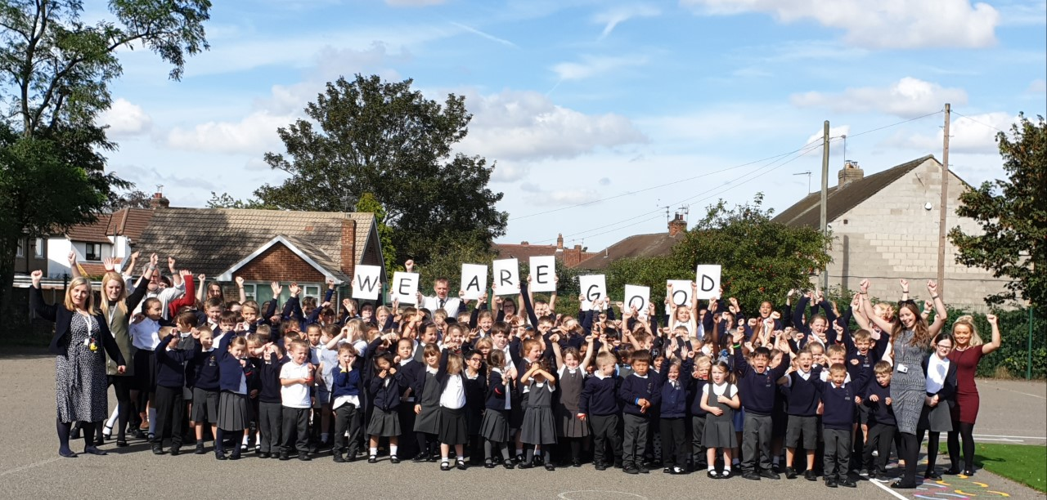

PRINCIPAL’S WELCOME
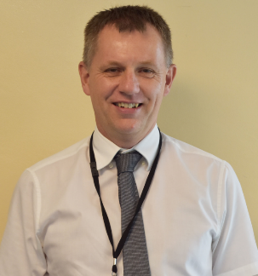
It is my pleasure to welcome you to our small but thriving primary school which continues to build on the Good rating given by OFSTED in July 2019. We really pride ourselves on our “family feel” and this is often commented on by people visiting the school. Our new parent handbook has been designed to give you a feel for the school and provide you with all of the information you need for the forthcoming academic year. The new year will bring challenges as we hopefully return to a greater sense of normality but we have made preparations to build on our engaging curriculum to really address everyone’s physical, emotional and social wellbeing. We pride ourselves on our wider curriculum offer and a visit to our website and Twitter feed should give you a greater feel for the range of experiences we aim to provide. Our ambition is that every child should reach their full potential and have their talents developed so that they can take their next steps successfully to meet their ambitions and aspirations. High expectations are held by the whole team at Edenthorpe Hall so that we get the best from each and every child in our extended family. Our vision statement and core values are at the heart of everything we do.
We are part of the Astrea Trust – a family of 27 schools across South Yorkshire and Cambridge. This gives us an extended network with whom we work to complement our relationships with the Hungerhill family of schools and the wider Doncaster network through Partners In Learning. Through this work we ensure that every member of staff receives ongoing high quality training based around research through opportunities to share the very best practice, meaning that our children benefit hugely. The Astrea Promise provides our commitment to our families for the whole experience.
I look forward to seeing you all in school again soon so that we can continue to work closely together to ensure our children have the best possible start in their lives, setting them up for a bright future in which anything is possible for them.
A MESSAGE FROM THE CHAIR OF LECC
On behalf of the Local Education Consultative Committee, I would like to warmly welcome you Edenthorpe Hall and Astrea Academy Trust.

We aim for the school to have a family and community feel, providing a welcoming and safe place in which children can develop their confidence and abilities, achieving their full potential in social, academic and other areas. At Edenthorpe Hall, every effort is made to realise the school vision so that ‘All children will have experiences which enrich their lives, enabling them to go on to fulfil positive roles in society and have a lifelong love of learning.’ This includes learning opportunities in sport, technology and the creative arts.

When we visit the school, children are happy, hard-working and polite, and emphasis is placed on each child’s individuality. Edenthorpe Hall provides ‘an inclusive environment in which children, regardless of background or barriers to learning, feel proud of their achievements.’

We look forward to a positive future and great collective achievement - welcome!

STAFF LIST 2020-2021
Principal | Mr Moody – Designated Safeguarding Lead, SENDCO, Pupil Premium lead
Vice Principal | Miss French - Y6 Class Teacher, lead for Maths, Curriculum, Assessment, Teaching and Learning, Behaviour, Deputy Designated Safeguarding Lead and Early Help practitioner
FS2 Class Teacher | Mrs Johnson – Astrea Promise lead
Y1 Class Teacher | Mrs Priestnall - Phonics, Art, D+T, PSHCE lead
Y2 Class Teacher | Miss Lomas – Science and PE lead
Y3 Class Teacher | Mrs Wheatcroft – STEM and computing lead
Y4 Class Teacher | Miss Beddoes – School Council lead
Y5 Class Teacher | Mrs Sykes – English and Music lead
 | Mrs Bratcher – working predominantly across Y5 and Y6 and lead for Humanities and Mental Health/Wellbeing.
Support Staff | Mrs Barrass – pastoral lead for EYFS/KS1 and lead on Speech and Language and Medical needs.  Mrs Williams – pastoral lead for KS2 and lead on Spanish and Attendance  Miss Adams – Sports Coach  Mrs Oldfield  Mrs Russell  Mrs Burd  Miss Black  Mrs Yasseen  Mr Lappin  Miss Lever
Admin Team | Mrs Hannam (Office Manager)  Miss Bardell (Office Administrator)
SMSAs | Mr Lappin  Mrs Fitzpatrick  Mrs Potter  Mrs Pinder  Mrs Holloway
Caretaker | Mr Smith
Cleaners | Mandy Holloway  Linda Kenny  Christine
Cooks | Debi Towler – Head cook  Gillian McLellan  Joyce Snow
LECC Members | Jenni Machin (Chair)  Jonathan Moody  Jasmine French  Michael Lappin  Andy Coy  Leslie Budhi  Paul Munby  Kate Saunders  Neil Cottingham  Ekanem Ibokessien  Becky Parkinson  Michelle Swift (Clerk)

SCHOOL DAY – September reopening plans
Class | Drop-off | Collection | Entrance for parents | Doors for children to enter/exit the building
FS2 | 9:00 | 3:00 | KS1 Playground Gate | FS2 Classroom Door
Y1 | 8:40 | 3:20 | KS1 Playground Gate | Y1 Classroom Door
Y2 | 8:40 | 3:20 | KS1 Playground Gate | Y2/3 Classroom Door
Y3 | 8:50 | 3:30 | KS2 Playground Gate | Y2/3 Classroom Door
Y4 | 8:50 | 3:30 | KS2 Playground Gate | Y4 Green Door
Y5 | 8:30 | 3:10 | KS2 Playground Gate | Y5 Door
Y6 | 8:30 | 3:10 | KS2 Playground Gate | Hall Door

It is essential that children arrive on time in order for their learning to start promptly. Children who arrive into class late miss out on an essential start to the school day including mindfulness mornings and meet and greet. These two activities set the tone for the rest of the day.
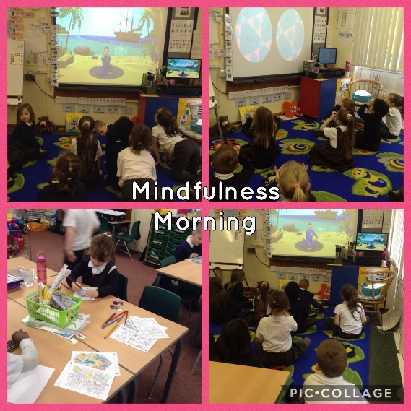
When children arrive, packed lunch boxes should be placed on trolleys and coats and bags should be placed on their own designated peg. Every class in school then participates in mindfulness mornings where they start the day with an activity focused on mental health and wellbeing.
If you wish to speak to school staff, please make an appointment with Miss Bardell at the office as teachers are not available at this time.

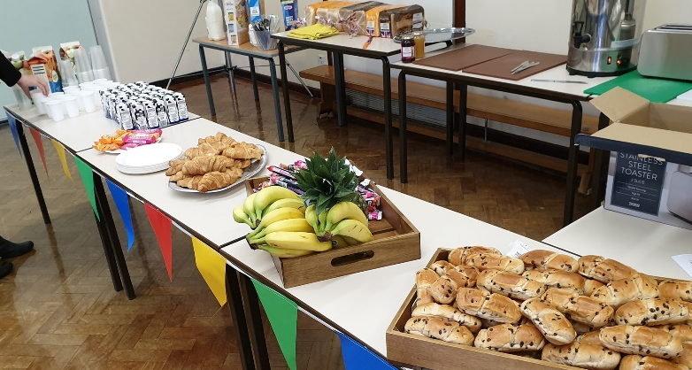
WRAPAROUND CARE
At Edenthorpe Hall, we aim to provide wraparound care from 7:30am-5:30pm subject to budget and staff appointments. Please see wraparound care leaflet for more information.
From 7:30 and 8:00am, FS2-Y6 children are welcome to attend breakfast club.
We offer a range of breakfast options: toast, cereal, fresh fruit, crumpets, pancakes, fruit juice and milk. There are also a range of activities happening including colouring, arts and crafts and sports.
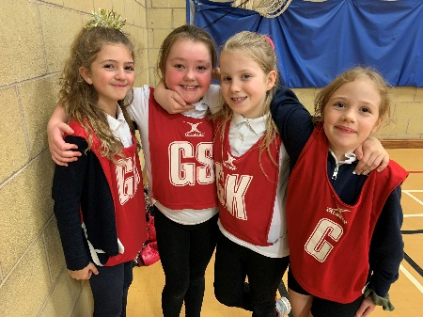
From 3:30pm, FS2-Y6 children can attend a whole host of clubs including STEM (Science, Technology, Engineering and Maths), film, baking and gardening. Most clubs run until 4:30pm but there will be sport clubs running until 5:30pm on each day too.
ATTENDANCE
At Edenthorpe Hall, attendance is a priority. Attendance has been found to be directly linked to attainment. There is a clear link between poor attendance and lower academic achievement. As well as this, pupils with persistent absence are less likely to stay in education after the age of 16. At Edenthorpe Hall, we deem good attendance to be 97% or more.
- Pupils should aim for 100% attendance
- 90% attendance means a pupil is missing the equivalent of ½ day of education every week.
- Pupils with 90% and below are classified as Persistent Absentees
- A pupil with 80% attendance all the way through secondary school (5 academic years) is the equivalent of missing a whole year of education.
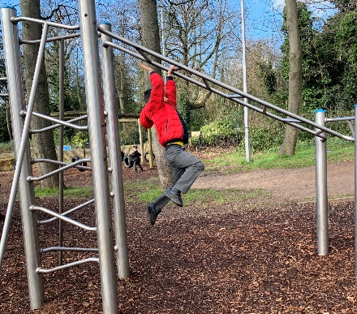
By law, parents have a duty to educate their children by ensuring regular attendance at school. Therefore, if your child is absent, school should be contacted by telephone (01302 882381) no later than 8:45am on the first morning of any absence.
If children have a record of poor attendance/punctuality or if school is not informed, the Education Welfare Officer may need to be contacted and warning letters may be sent out. To encourage good attendance, children are rewarded in a variety of ways including certificates and class Dojos. Attendance figures are also featured in our newsletters.
Holidays in Term Time
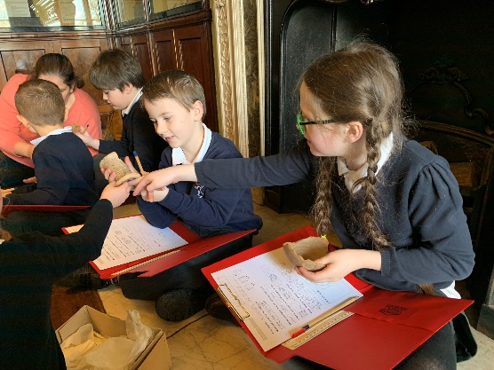
No requests for holidays can be authorised except in exceptional circumstances. In such instances, you should contact Mr Moody. Any family taking a holiday without authorisation may incur a fixed penalty notice of £60 per child. After 21 days, if the penalty notice is not paid, it will increase to £120.
Medical Appointments
Parents must notify Miss Bardell in the school office if they wish to collect their children from school for a medical appointment. Children will only be able to leave school if collected by their parent or authorised adult. Your child will then be signed out of school.
Illness
Children who are clearly unwell should not be sent to school. You should contact the school office and explain the reason for absence. If we do not receive a call by 8:45am and your child is not in school, we will contact you to enquire the reasons for your child’s absence.
If a child becomes unwell at school, we will contact the child’s parents/carers as soon as possible. Therefore, it is paramount that we have current emergency contact details.
Medicines
If it is necessary for children to take a prescribed medication during the school day, it needs to be brought to the school office by a parent/carer and a medication form needs to be completed and signed. The medicine should include the child’s full name and dosage requirement and it will be stored safely in the office.
Children who have asthma will have their inhaler stored in the classroom cupboard so that it can be accessed quickly. If a child is given their inhaler during the school day, you will receive a slip notifying you of this.
MENTAL HEALTH AND WELLBEING
At Edenthorpe Hall, we believe that our role is to ensure that the mental health and wellbeing of our whole school community is at the heart of everything that we do. In school, Mrs Bratcher is the designated mental health lead and all of our staff are trained to spot any emotional or behavioural problems quickly. As well as this, Mrs Barrass and Mrs Williams are the pastoral leads for EYFS/KS1 and KS2.

In light of the recent Covid-19 pandemic, we believe that mental health and wellbeing needs to be our number one priority in September. We understand that children will have different thoughts and feelings about returning to school after such a long break but we will work hard to support them in many different ways.
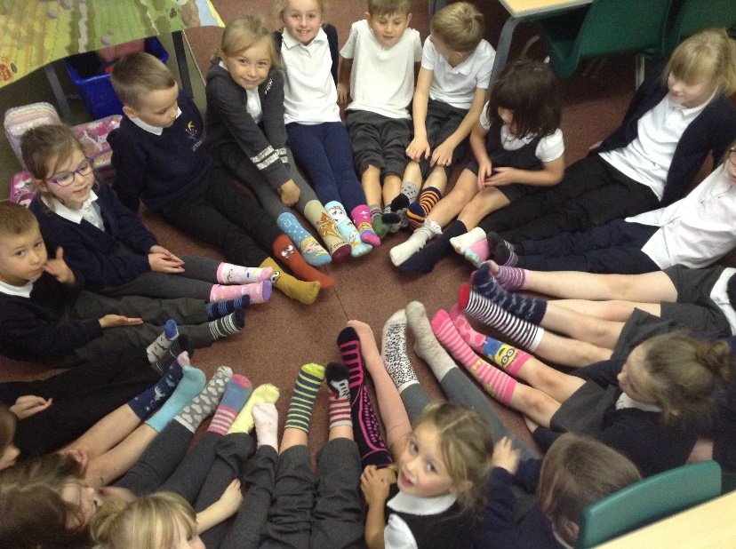
In order for children to transition back into normal school life, we will be implementing various new initiatives. Some of these include: mindfulness mornings, team building activities to rebuild social skills and regular circle time activities to encourage children to discuss and reflect on their emotions. We appreciate that some children have missed a whole term of academic learning and staff will work hard to catch-up on lost time.
SCHOOL REWARDS AND SANCTIONS
At Edenthorpe Hall, we expect a high standard of manners and behaviour from all pupils. From September, we will be using Class Dojos as our reward system and parent communication tool. Teachers will share pictures to celebrate progress and achievements that children have made. Please note that the Class Dojo app should not be used to communicate any parental concerns/absences. This should still be communicated formally through the office. Teachers will also have ‘quiet hours’ turned on to indicate times where they will not be contactable. Children will be able to earn Dojos for consistently following our mission statement ‘we inspire, we believe, we challenge, we achieve’ and for displaying our school values – respect, resilience, aspiration, honesty and enjoyment. Children’s Dojos will be reset weekly and the children with the most amount of Dojos in each class will receive a ‘Dojo Champion’ certificate.
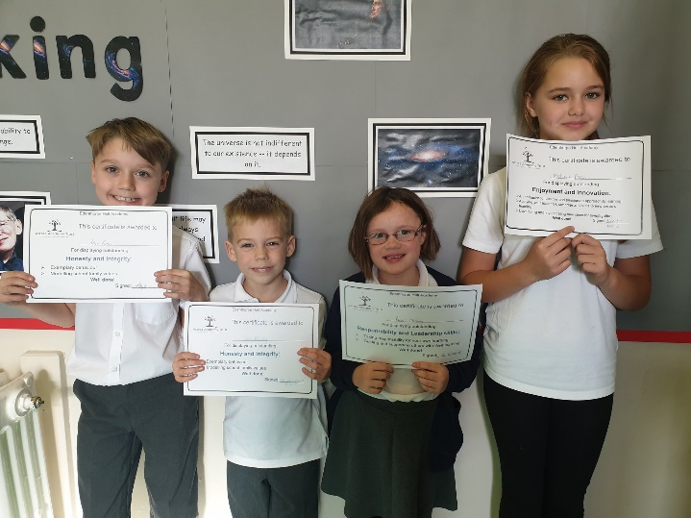
In addition, we celebrate success during our weekly celebration assembly where children can achieve a certificate for showing a particular key value. At the end of every term, we celebrate Pupil of the Term. The teachers nominate two children who have displayed outstanding effort during the term and parents are invited in to celebrate this event. This is a very special assembly. Finally, children who have been spotted for excellent effort or behaviour during the week can be nominated to attend ‘Hot Chocolate Fridays’ with Mr Moody or Miss French.
Class Dojos will be awarded for:
- Showing the school’s key values in the way in which they behave
- Consistently following/applying our mission statement
- Consistent effort towards learning
- Success in a particular subject
- Significant improvement in any area of the curriculum
- Consistently noticed by other members of staff around school or in assembly for displaying impeccable manners and behaviour
- When the whole class achieve 100% attendance
- Supporting other children with their learning
- Being an excellent role model
At lunch time, children can also earn Dojos. SMSAs will award Dojos for:
- Excellent manners and behaviour
- Playing cooperatively with others all week
- Being helpful
- Good movement around school
- Being a good friend to others
- Supporting other children at lunch time.

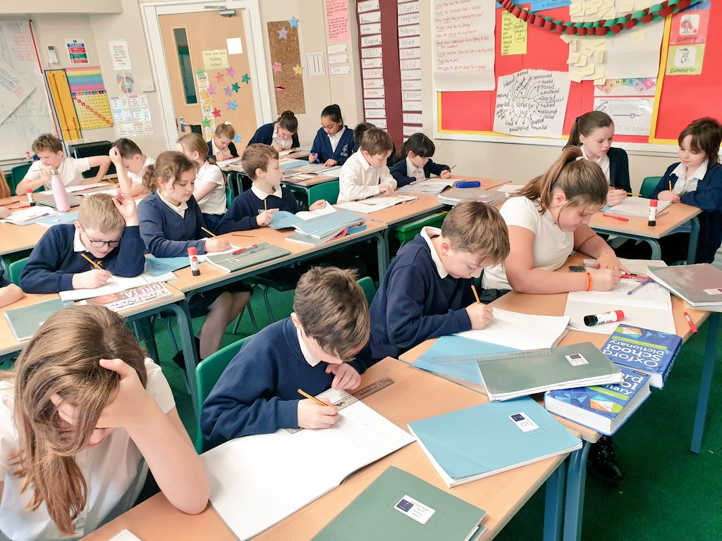
BEHAVIOUR
At Edenthorpe Hall, our primary aim is for the children to feel valued and respected, and that each person is treated fairly and well. We have a positive school climate underpinned by three core principles; ready, respectful, safe. Every morning, class teachers will meet and greet children at the door which supports us in ensuring children have a positive start to their school day. In addition, we focus on positive language not negative. We ensure that at all times staff model the positive behaviour expected of the children and build relationships. In order to gain children’s attention, we use hands up for silence and work hard to instil a calm, purposeful atmosphere around the school site.
On the rare occasions that children do not display the expected behaviour, we have a procedure that all members of staff follow.
1 – Children are given a gentle reminder of the expectations ready, respectful and safe.
2 – Children will be given 2 very clear verbal warnings. This will make the children aware of their behaviour and outline the consequences if they continue. We will also remind them of their previous good conduct.
3 – Children will be given a final warning.
4 – If unwanted behaviour continues, the child will be escorted to a different classroom where they will work and reflect on their behaviour for an age-appropriate time.

Any child who is sent to a partner class is expected to attend a restorative meeting where a member of staff will support them in reflecting on their behaviour to ensure that this behaviour does not happen again. This incident will be communicated to parents and logged on our school system.
If there are any more serious or prolonged behaviour issues, you will be invited in to school for a meeting to discuss further procedures.
UNIFORM
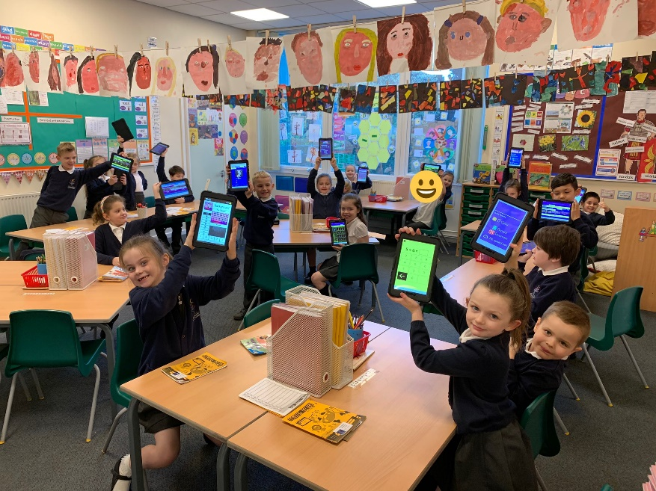
All children are expected to wear school uniform. We are very proud of our uniform and the children always look very smart! Wearing uniform provides children with a sense of belonging – belonging to our wonderful Edenthorpe Hall family!
Children must be encouraged to take responsibility for their belongings and we ask that all items of clothing are marked clearly with your child’s name.
Children are not allowed to wear jewellery in school except a pair of stud earrings. However, children must be able to remove them independently for PE lessons.
School uniform can be purchased here: https://www.quickstepsdoncaster.co.uk/schoolwear/schoolwear-edenthorpe-hall/
The wearing of make-up and nail varnish is not permitted. Hair should be tidy and tied back if long.

Our school uniform is as follows:
- Navy blue sweatshirt/ navy blue cardigan – logo or no logo
- White polo shirt or white shirt/blouse
- Grey trousers/skirt/pinafore dress – leggings are not permitted
- Grey/black/white socks or tights
- Sensible black shoes (no trainers/heels)
School uniform with the logo can be purchased through Quicksteps Doncaster: https://www.quickstepsdoncaster.co.uk/schoolwear/schoolwear-edenthorpe-hall/
The remainder of the uniform may be obtained from a wide variety of retail outlets.
Our PE uniform is as follows:
- White T-shirt
- Black shorts
- Black socks
- Black or grey tracksuit for outdoor PE
- Black pumps for indoor PE and trainers for games sessions
Pupils are expected to wear their PE kits to school on the days they have PE until current restrictions are lifted around changing facilities in school. PE days will be shared by your child’s class teacher.

Pupils who need to be excused from lessons for medical reasons should still wear their PE kit. It is important to continue to develop PE knowledge and skills through less physical aspects of the work: coaching, planning and evaluating.

Personal Belongings
Children should not bring any stationery, pencil cases, toys, sweets or large amounts of money into school. It can be a distraction for the children and upsetting if their belongings get lost of broken. A lot of learning time can then be wasted on resolving any issues. Y6 only are permitted to bring in mobile phones if they are walking to and from school. Mobile phones are signed in and out and are stored in the school office.
SCHOOL MEALS
School meals are cooked fresh on site. They offer a nutritious, hot and well-balanced meal. There are a wide range of options on the menu which is sent home to parents. You can then discuss your child’s meal choice with them before they order during registration. School dinners are provided by the company Chartwells and they work hard to cater for all dietary requirements.
School dinners cost £2.50 per day. If you feel you may be entitled to free school meals, please see Miss Bardell in the office who will be happy to support you.
We are a healthy school and so encourage children to eat a balanced and healthy meal. In order to promote healthy eating, children are only allowed fruit snacks at playtimes and we run a healthy tuck shop which stocks a range of snacks and juice.
CURRICULUM
At Edenthorpe Hall, we offer a broad, balanced and ambitious curriculum. We aim to ensure that all students achieve well in the core subjects due to engaging teaching which is research-informed and rooted in strong subject knowledge. We follow the National Curriculum and have invested in suitable schemes to ensure learning is fun and relevant. Our wider curriculum is focused on the children developing their knowledge through a carefully-sequenced, progressive curriculum. As a school, our goal is to ensure that children are given the knowledge and cultural capital they need to succeed in life.
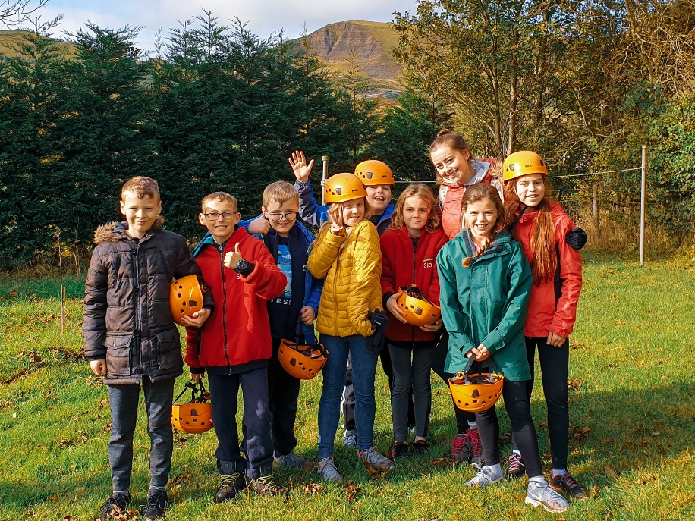
Throughout the year, we hold various curriculum events where parents are invited in to school to celebrate children’s learning. We thoroughly enjoy these events where we collaborate with you and your families.
In addition, every half term, you will receive a curriculum map which outlines what your children will be learning across the wider curriculum.
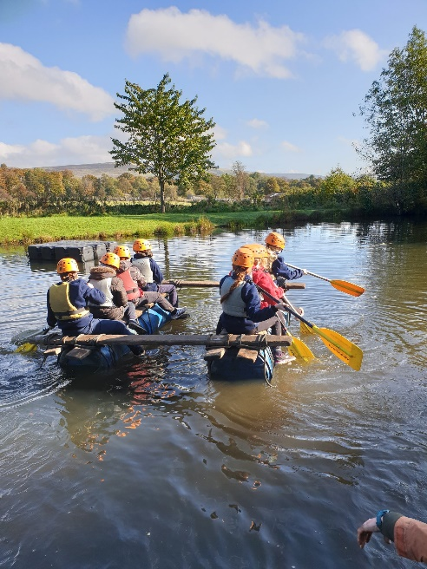
PROVISION FOR CHILDREN WITH SEND
As a fully inclusive school, we will ensure that whatever the child’s needs, we will do our utmost to make sure they can access an appropriate curriculum. This may mean that some children require a highly differentiated curriculum whereas some children will require further resources such as adult support in order to access an age-appropriate curriculum. When children are on the SEND register, they will have a support plan which outlines their specific targets. These targets will be reviewed termly with yourself as parents, your child, the SENCO and the child’s class teacher. Parents are fully involved at all stages and can be reassured that decisions regarding the child will only be made with your consultation.
If you have any concerns regarding your child, please contact Mr Moody who is acting SENCO from September 2020.
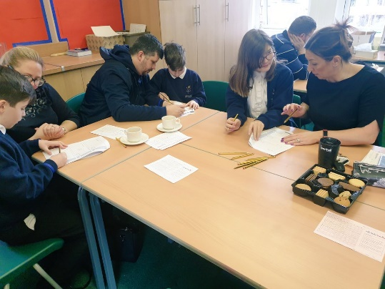

LEARNING AT HOME
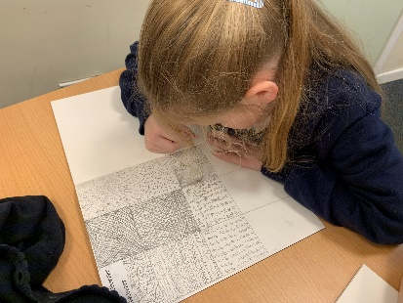
All children are expected to read at least 3 times every week and they should be encouraged to read aloud to an adult or older sibling. Reading is a very important part of our curriculum and we encourage you to support us in developing a love of reading. Children from Y2-Y6 take part in the Accelerated Reader programme which aims to ensure all children are reading at the correct level. When children have read a book, they will complete a quiz in school to check their comprehension. Your child’s class teacher will then work with your child to ensure that they are choosing the correct book for their ZPD range.
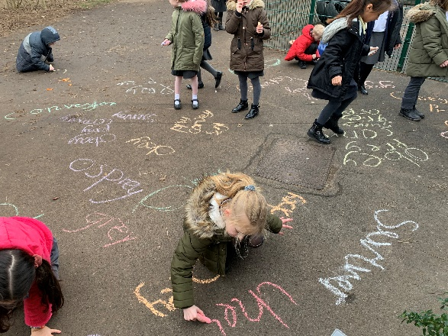
We also actively encourage regular practice of times tables and spellings. Each week, children will have a spelling test and they should practice at home on Spelling Shed. Times tables are also a fundamental part of the maths curriculum and children should access Times Tables Rock Stars to ensure they are fluent in recalling their tables.

Thank you for taking the time to read our Parent Handbook.
We look forward to working with you.

