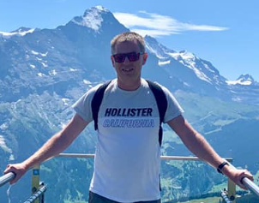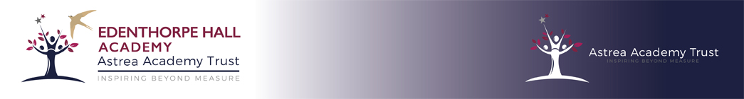

**About me!**

Outside of school I keep myself busy in many ways. I enjoy going to the gym on a weekly basis where, as well as using the machines and weights upstairs, I also enjoy swimming. I also keep fit through walking regularly and love going to areas such as the Peak District and the Lake District in this country and to countries such as Austria and Switzerland to escape everything and everyone and enjoy the breath-taking scenery.

I love travelling in general – particular favourites in the UK are Devon (lots of childhood memories there) and the Brecon Beacons and worldwide Mexico, Jamaica and Canada.

I regularly go to the cinema and theatre and enjoy getting lost in a good book. I sometimes run a music quiz night in my home village and am a member of a local fundraising Lions group. I was just elected their Activities Chair before lockdown so I have not had much to organise as yet but I’m looking forward to organising events such as Bonfire Night in the village and the Santa sleigh in December for them.

**Introduction**

I’m Mr Moody – the Principal at Edenthorpe Hall since September 2017. I have been a Head Teacher now for ten years, having worked for many years before that as a class teacher in all year groups from Y3 to Y6 in a variety of schools. Being Principal means that I have the privilege of making a difference to the lives of hundreds of children every year so that they can unlock their potential and develop their unique talents and personalities. It is important to me that every member of our school family has high expectations of themselves and each other along with a belief that anything is possible. Our core values are important to me as they are essential for not only life-long learning but for being the absolute best person that we can be. The next year will hold many challenges as we return to some sort of normality but together we can face these with strength and commitment to improvement.

**Education**

I left school many years ago in the days where students still did O Levels. After completing my A Levels I moved away to study in Lancaster for four years. During that time I completed my degree in Primary Education and Geography. While in Lancaster I made a number of close life-long friends around the country who I still meet up with from time to time.I taught in four different schools before my first Headship in Rotherham in 2010. During that time I spent many years in Y6 but also taught all other KS2 year groups. I completed my National Professional Qualification for Headship in Leeds in 2006. I moved to Edenthorpe to work with Astrea in 2017.