Instructions for logging on
Go to https://inourplace.co.uk/
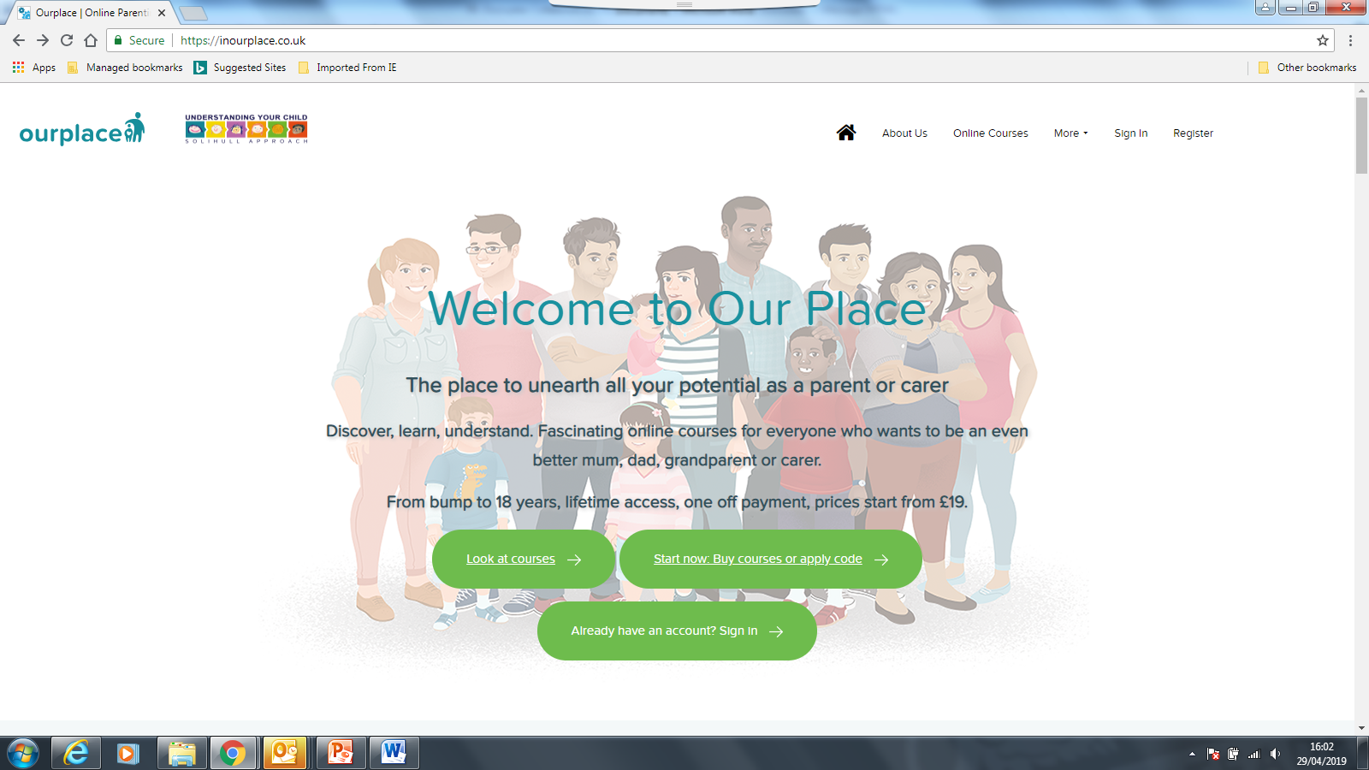
Click here
You will then be in the Course Library.
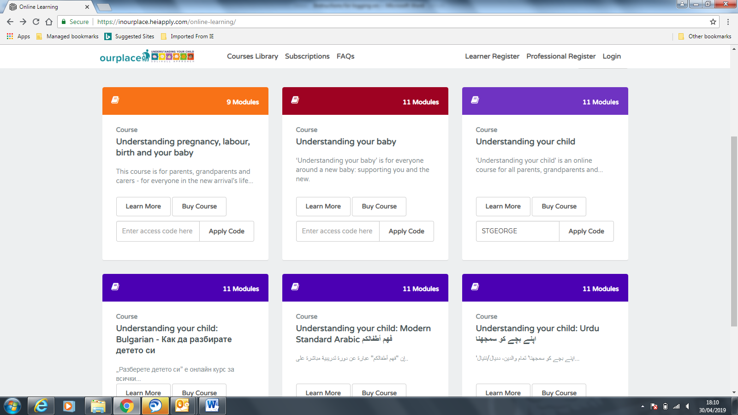
Enter the access code STGEORGE against the course you would like to start.
You will then need to fill in some basic demographic information in order to validate a Doncaster postcode and to create an account, so you can log in and out at your leisure.
- Your information
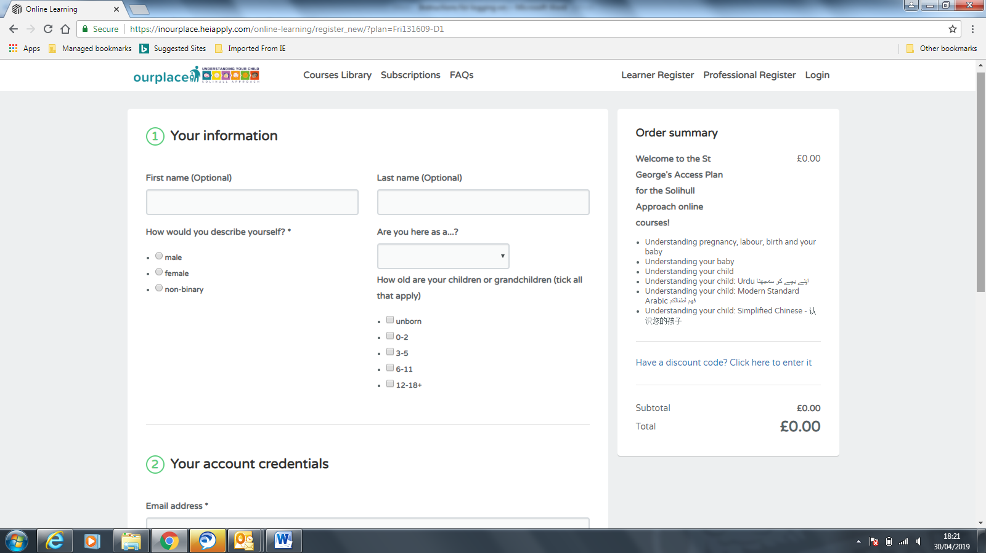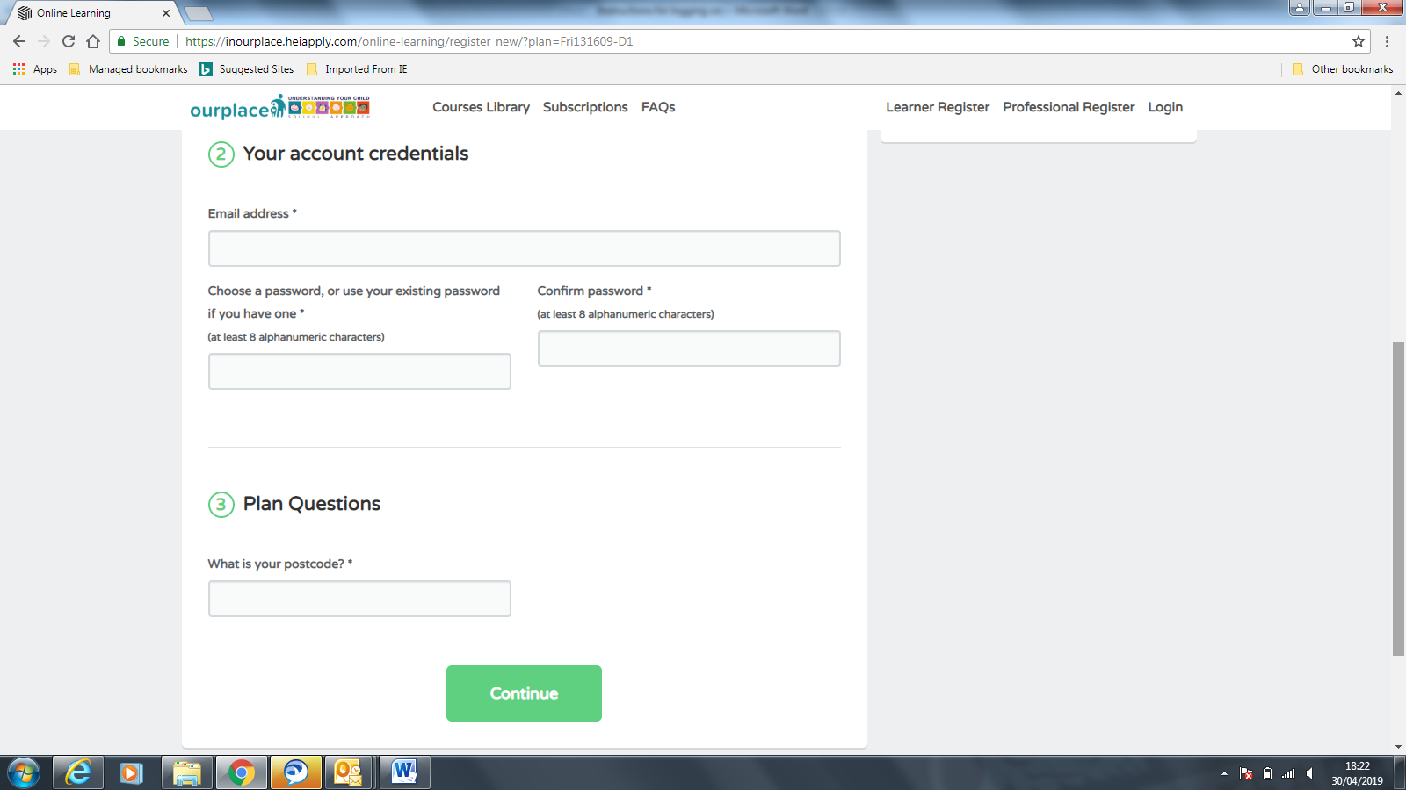
- Your account details.
- Confirm your postcode as a Doncaster postcode.

To start your selected course or to start another course, click on Dashboard and then view course against your selected course.
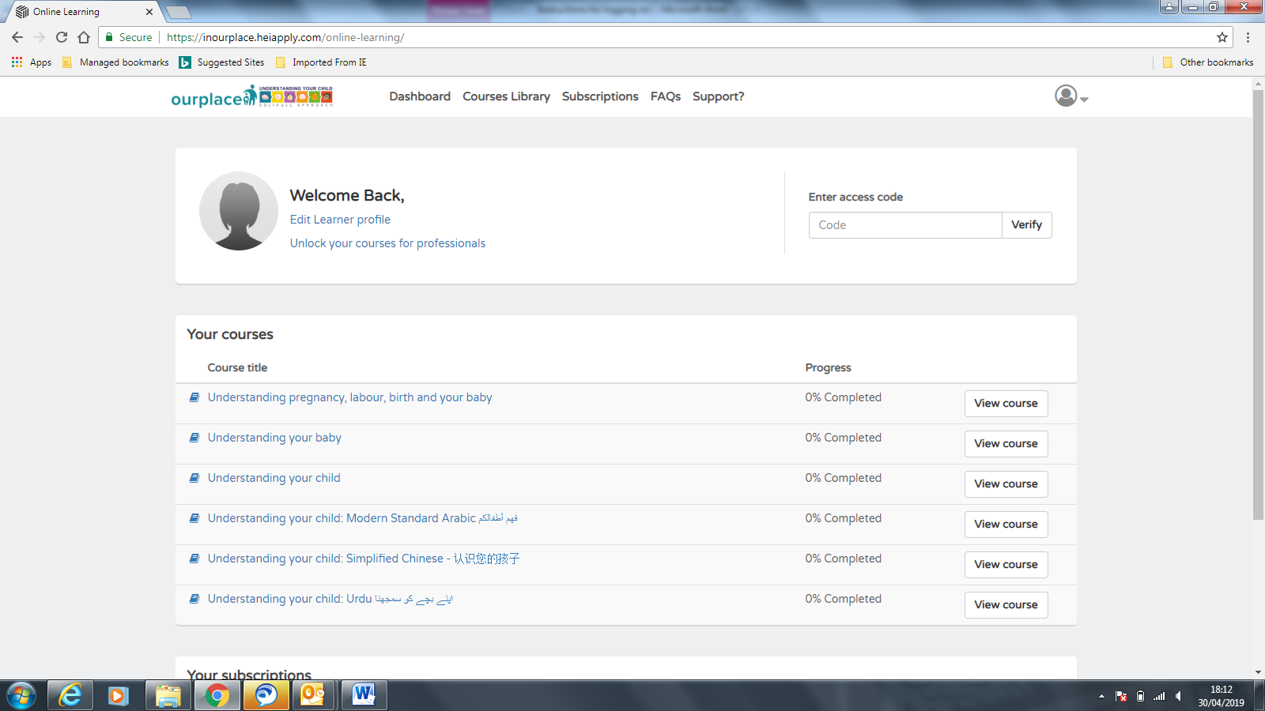
Follow the instructions on the screen or given in the voice over.
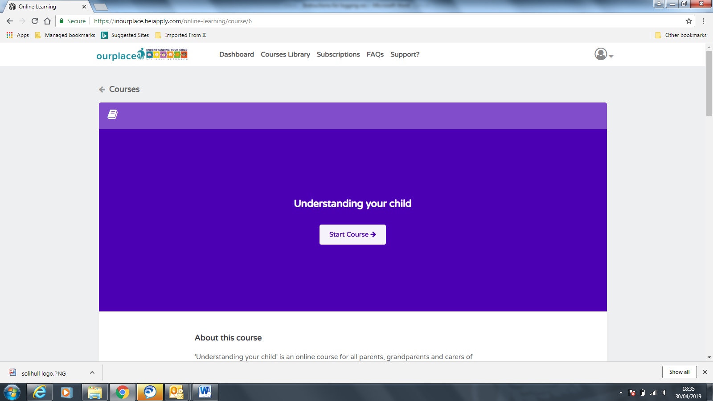
It’s Easy to navigate….
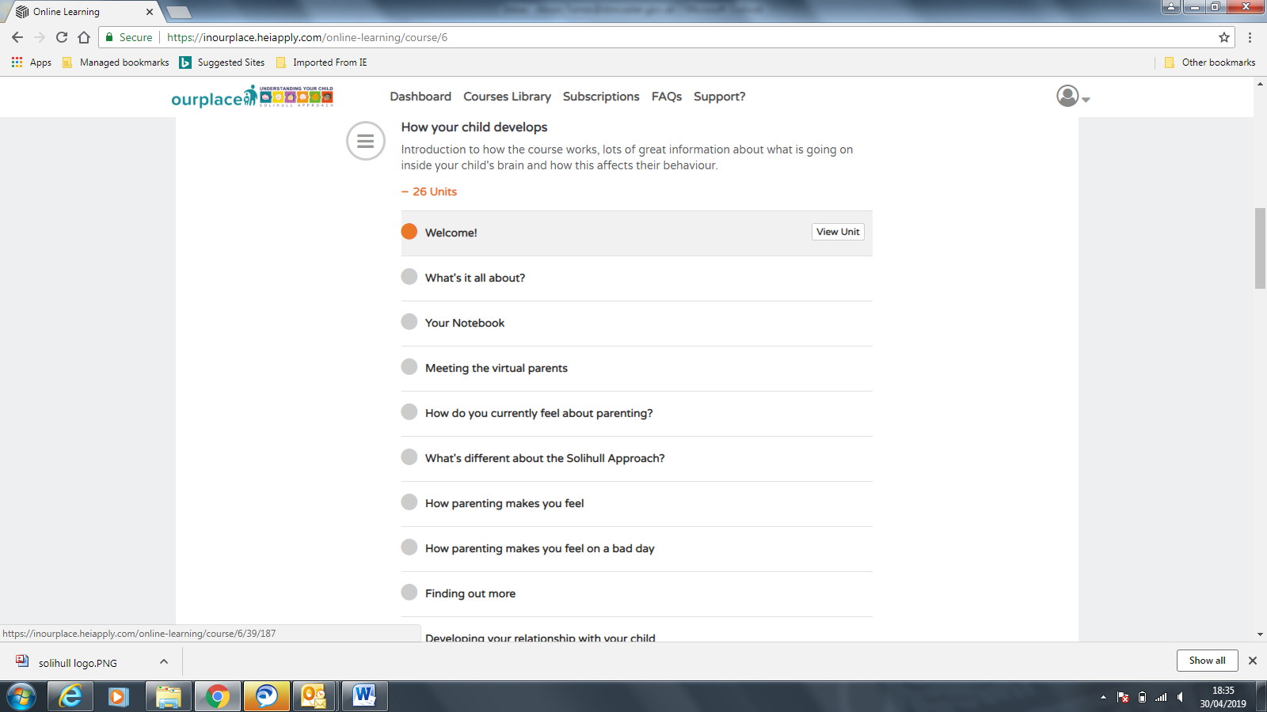
You can start and stop the course as many times as you like via the Dashboard, and return to where you left the course. Just make sure you mark each Unit as complete when you see this image in order to move on to the next unit.

