English; Spelling
Planning, Delivery and Assessment
2018/2019

Planning
Oxford Owl - Read Write Inc. Spelling Programme
https://www.oxfordowl.co.uk
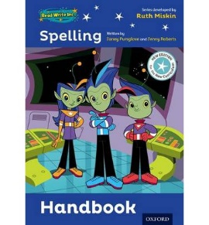
- Follow your year group’s scheme of work as set out in the spelling handbook

- Discrete spelling session delivered daily for 15-20 minutes, clearly indicated on your weekly timetable
- For homework - Choose 10 words to compliment the pattern/sound being taughtand in addition children to also be set 5/10 words from the Y3/4 or 5/6 spelling lists as homework

Teaching
- Use the RWI online resources and children’s work books/log books to deliver the programme for your year groupbeing taught
- Each RWI unit is to be delivered over 5 sessions as set out in the handbook
- The spelling lesson can be taught by the class teacher or an LSA
- Examples of words containing the newly learned patterns/rules should be added to the working wall to aid memory retention/rehearsal

Assessment
- Children to take a weekly spelling test (set day of the week) which focuses upon the newly learned pattern/rule
- Spelling tests to be recorded into English books to monitor progress
- Children to mark their own spellings as guided/modelled by the teacher (refer to dots and dashes, Fred Fingers etc.)
- Children can make corrections in purple pen
- Class teacher to record scores for every unit onto a class list and up-load into the Teacher’s Drive
- One weekly intervention session to be dedicated to practising the newly learned pattern/rule with the children scoring less that 7/10 to ensure all ‘keep up’ with ARE taught patterns. The ‘Whole Word’ approach can be used to support the acquisition of new patterns/rules
- Test Base mid-term and end of year tests to be used in accordance with the school assessment timetable to measure progress and provide summative assessment against ARE

SEND
For children who are significantly behind Age-Related expectations, an individual assessment must be carried out in order that they make continue to make progress from a relevant identified starting point. These children will then work through the relevant teaching units in same-ability groups with a teacher.

